VARUN GOYAL
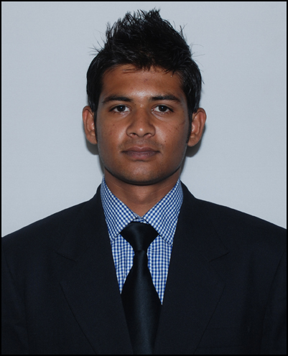

+91-9742731696
varungoyal3231@gmail.com

CAREER OBJECTIVE
Open to work in any industry.
Seeking assignments in a challenging job environment that utilizes my skills and abilities and offer ample learning opportunities. Try to create value for the industry and grab opportunities to achieve organizational goals effectively and efficiently with the knowledge I have gained through my studies and experience.

RESUME SUMMARY
Committed, initiative taker, punctual, passionate, creative, team worker, quick & continuous learner, relationship building.

EDUCATION
• | 2013- MBA in Marketing from Alliance University | 1.8(69%)
• | 2011 – BBM from GARDEN CITY COLLEGE Bangalore, BANGALORE University | 66%
• | 2008 - Class 12 from NIRMAL DEEP PAGARANI PUBLIC SCHOOL , CBSE | 69.4%
• | 2006 - Class 10 from NIRMAL DEEP PAGARANI PUBLIC SCHOOL, CBSE | 59.8%

EXPERIENCE SUMMARY
Working as a Sr. Relationship manager- Bajaj Allianz Life Insurance co. ltd( Aug 2013- till date)
JOB PROFILE
- Working in Bancassurance channel (CITI bank) and sales only in IT corporates.
- Managing and building client and intermediary relationship for new business development and retention of the existing business.
- Arranging Client engagement programme to ensure customer retention.
- Monitoring delivery of high-quality customer experience, elevating customer satisfaction.
- Giving Presentation in induction for sales.
- Work on Lapse cases and convince them to reactivate their policies.
Worked as a Business Development Executive -Your kids ‘R’ our kids(Mar2013- July2013)
JOB PROFILE
- Sold company services to B2C & B2B and achieved a defined sales target.
- Identified customer needs and developed value added proposition proposal and pricing.
- Researched and identified market prospects and targets.
- Assessed clients need for services.
- Scheduled and arranged for new client appointments and calls for corporate tie-ups for employer-employee benefit programme.
- Developed systematic marketing campaign.

INTERNSHIP
OPEN MEDIA NETWORK Pvt. Ltd.(In BBM),
Fit kids Education & Training Pvt. Ltd.(during MBA)
Title | A study on CONSUMER AWARENESS TOWARDS OPEN MAGAZINE.(BBM)  Analyzing & Mapping various summer camps running in Bangalore.(MBA)
Description  (BBM) | - Met with top level management people of organizations, schools, colleges of Bangalore  - Created awareness about OPEN magazine  - Marketed magazine & try them to subscribe for the magazine
Description  (MBA) | - Created brand value in the eyes of respondents  - Collected data of 200 companies & took surveys of 600 people.  - Analyzed the collected data & recommend through which organization can get competitive advantages in summer camps & against their competitors.  - Concept presented for fresh face of website.

AWARDS & ACHIEVEMENTS
Extra-Curricular | - Achieved quarterly target in a month.  - Proficient in Microsoft Office, Outlook, PowerPoint, Excel.  - State level cricket u-15 & u-17 winner.  - Inter College Cricket Tournament winner, Man of the Tournament.  - Part time job in BIEC (Bangalore International Exhibition Centre) as assistant manager.(5 times for 15 days continuously)  - NSS team for two years.

INTERESTS
- Playing and watching Cricket, Table-tennis, Football, Badminton
- Stock Market, listening & following current affairs and politics
- Movies and listening to music
- Cooking Food

PERSONAL DETAILS
Address | #19/2,2nd floor,2nd CRS, chikkadugodi,Thavarekere main road, DRC post-560029
Date of Birth | 3 January ,1991
Languages | English, Hindi

